**EXPERIMENT NO – 1 DATE –**

**DIVIDE AND CONQUER**

**Theory –**

**General Method**

Divide-and-conquer is a problem-solving strategy that breaks a large problem into smaller, more manageable subproblems. The process involves:

1. **Splitting the Problem:** Divide the input into distinct subsets, where , resulting in subproblems.
2. **Solving Subproblems:** Solve each subproblem independently, often recursively.
3. **Combining Solutions:** Combine the solutions of the subproblems to form the solution to the original problem.

If the subproblems are still large, the process of division can be reapplied until the subproblems become small enough to solve directly. Typically, the subproblems are of the same type as the original problem. This approach is naturally expressed as a recursive algorithm.

**Control Abstraction**

To better understand the strategy, consider the general form of a divide-and-conquer algorithm:

1. If the input size is small enough, solve the problem directly.
2. Otherwise, divide the problem into smaller instances .
3. Recursively solve these smaller problems.
4. Combine the solutions of the smaller problems to obtain the solution to .

**Algorithm : DandC**

Algorithm DAndC(P):

if Small(P) then

return S(P);

else

divide P into smaller instances P1, P2, ..., Pk;

Apply DAndC to each of these subproblems;

return Combine(DAndC(P1), DAndC(P2), ..., DAndC(Pk));

* **Small(P):** A Boolean function that determines whether the input size is small enough to solve directly.
* **S(P):** The solution for small problems.
* **Combine:** A function that merges the solutions of subproblems.

**Time Complexity**

The time complexity of a divide-and-conquer algorithm is generally expressed by a recurrence relation. For instance:

* : Total time for an input of size .
* : Time for directly solving small inputs.
* : Time for dividing and combining solutions.
* : Time for solving each subproblem.

For many divide-and-conquer algorithms, the recurrence takes the form:

Here:

* : Number of subproblems.
* : Factor by which the input size is divided.
* : Time for dividing and combining.

**Solving Recurrences**

One common method for solving such recurrence relations is the **substitution method**, which involves:

1. Repeatedly substituting the recurrence formula into itself.
2. Simplifying until all instances of are eliminated.
3. Summing up the resulting terms to obtain a closed-form solution.

**INPUT -**

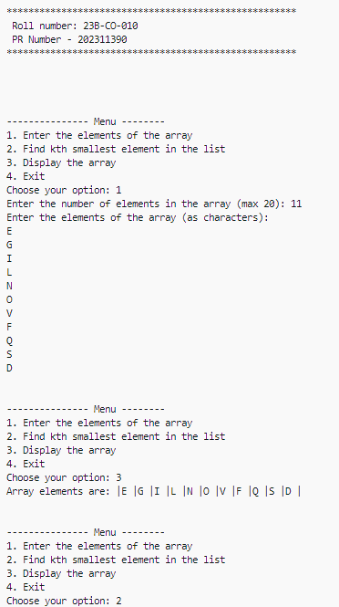

**OUTPUT –**

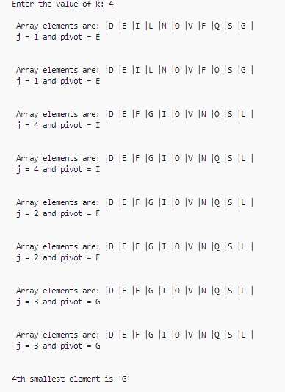 **I] K = 4 II] K= 9**

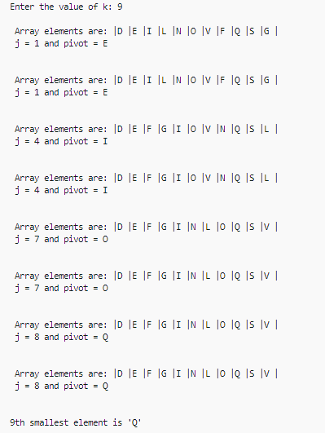

**TIME TAKEN –**

**I] K = 4**

 

**II] K = 9**



**CONCLUSION –** The kth smallest element was calculation sucessfully using select algorithm without any errors .

**INPUT –**

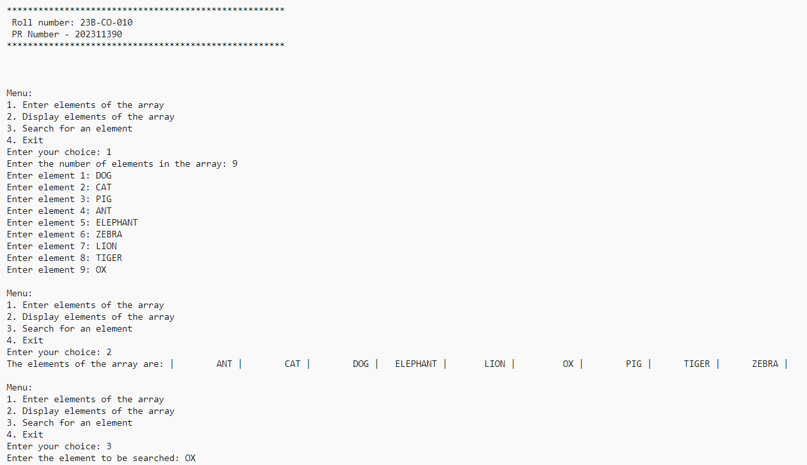

**OUTPUT –**



**TIME TAKEN –**



**CONCLUSION -**  Binary search on array of strings was successfully executed without errors